Aris Koumis

Professor Bond

CMPE 172-02

2/18/19 (Late)

Assignment #1 Report

Using Ansible, I have remotely configured a EC2 Instance to run an Apache webserver. My ansible playbook consists of two plays, each with a tag corresponding to their use case.

**Using my Playbook:**

Starting: The tag “start_web_server” is used to configure my EC2 instance.

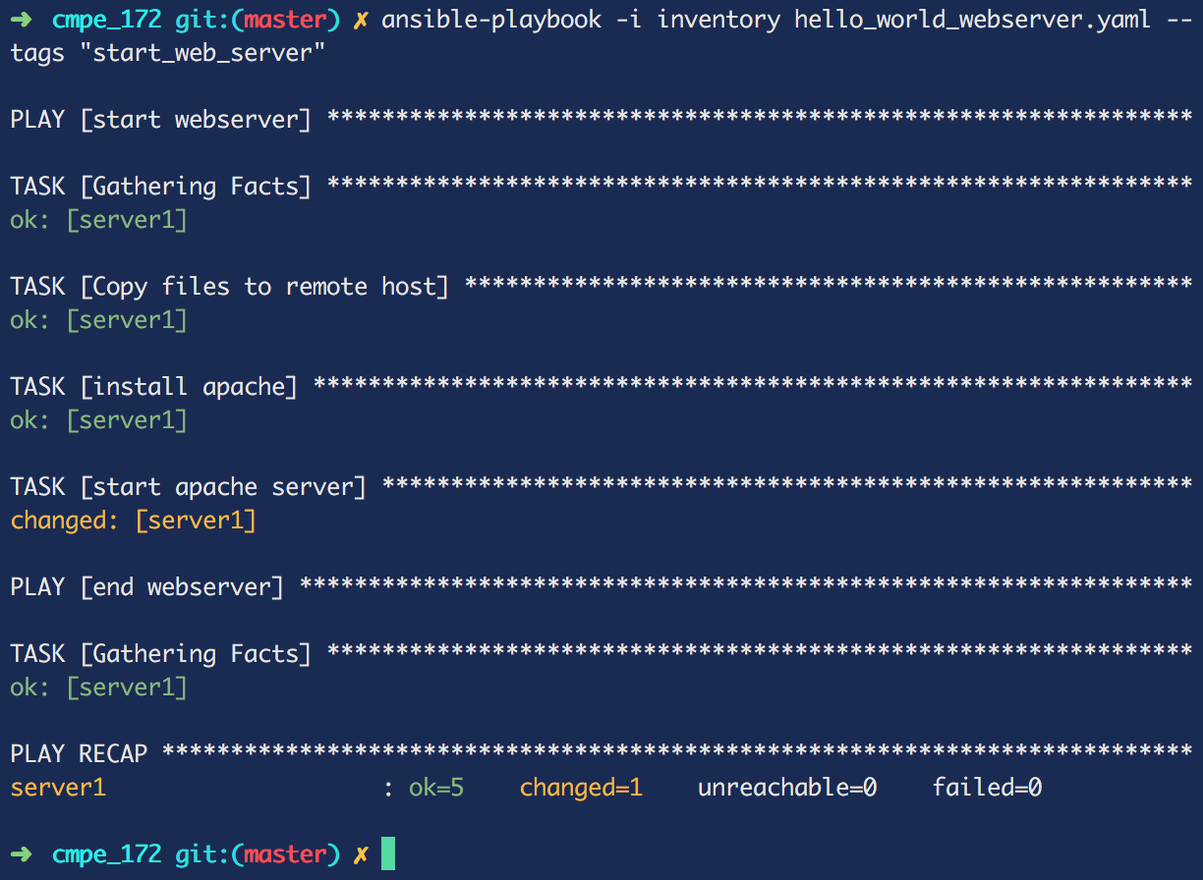

Stopping: The tag “stop_web_server” is used to kill all httpd processes on the host machine, thus stopping the apache webserver.

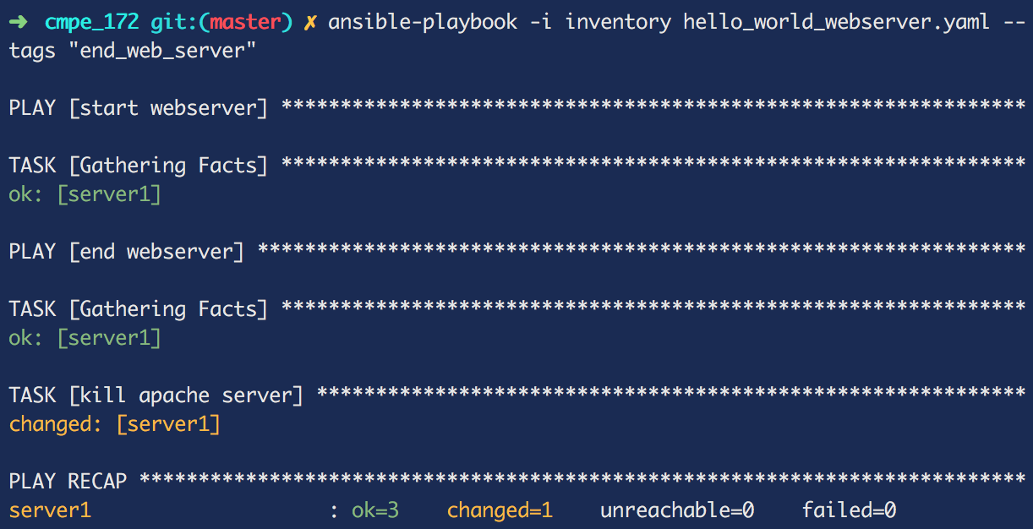

**End Result:**

My webapp is listening on port 80 of <http://ec2-52-52-128-162.us-west-1.compute.amazonaws.com/>. Check it out!